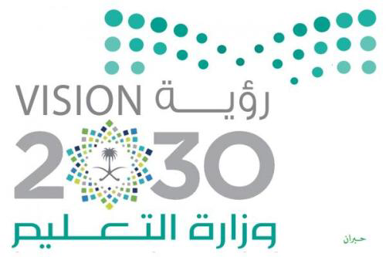

World Space Week 2019

The first Al-Ladam Medium of Wadi Al-Dawasir Education Office at the General Directorate of Education in Riyadh Region was implemented on Thursday, 25 February 1441, in activation of the World Space Week 2019 program (World Space Day) by the pioneer / Ghazel Ma'ani under the supervision of the school leader Noura Saad. Introducing students to a week
Space and the developments that have taken place by clarifying the most important arrivals of space vehicles and moons, as well as the definition of students first Saudi astronaut and everyone who was credited with the discovery of the universe.
The program was done through social media (Snapchat Twitter), and provide a morning radio to introduce the program and the most important related to it, with a video presentation on space, and the program also included a coloring competition between students and the exchange of discussions about the program.

